|  |  |  |  |
| --- | --- | --- | --- |
| **Team number** | 7 | **Section** | 03 |
| **Team Members** | 1. Jia Siang Fung 2. Brendan Chao 3. Tatsuya Hayashi | | |
| **Software Name** | Appliance Manager | | |

## Problem Statement

This software controls different appliances in your house that have bluetooth compatibility all from one application.

The software allows the user to add a new appliance based on the type of appliance it is. They can also choose to delete ones that have already been set up.

The user chooses the name for the appliance and the software automatically detects nearby bluetooth-compatible appliances fitting the type.

The user can choose from different functionality depending on the type of appliance they are trying to control.

For example, TVs will have functionality such as turning up and down volume, or turning it on. Air conditioners can have functionality such as adjusting the temperature. Ovens can set the timer and temperature before starting it.

The functionality will be issued through a user interface after selecting the appliance the user had already set up. This interface will be in the form of different buttons and sliders for each function that the user can interact with.

## Product Objective

This product solves the problem of convenience by giving users a way to remotely control appliances from anywhere in and outside the house. Through this application, users will have easier access to their appliances and the application will make these tasks simpler and more time efficient to do.

## Functional Requirements

1. The product allows the user to add a new appliance
2. The product allows the user to control an appliance remotely
3. The product allows the user to delete an appliance that is already set up
4. The product allows the user to create a new room.
5. The product allows the user to delete a room, including all of the room’s appliances.
6. If the user selects a set up appliance of type oven, a user interface will appear, allowing them to set the timer and temperature, as well as starting the oven. A timer will count down the time after hitting start.
7. If the user selects a set up appliance of type air conditioner, a user interface will appear, allowing them to switch on or off and increase or decrease the temperature.
8. If the user selects a set up appliance of type doorbell, a user interface will appear, allowing them to open the gate for a guest.
9. If the user selects a set up appliance of type light, a user interface will appear, allowing them to turn the light on or off, as well as controlling the level of brightness through a sliding scale.
10. If the user selects a set up appliance of type refrigerator, a user interface will appear, allowing them to increase or decrease the temperature.
11. If the user selects a set up appliance of type speaker, a user interface will appear, allowing them to turn on/off, raise/lower the volume, and mute/unmute the speaker.
12. If the user selects a set up appliance of type TV, a user interface will appear, allowing them to turn on/off, switch between channels, raise/lower the volume, and mute/unmute the TV.

## Use Cases

|  |  |  |  |
| --- | --- | --- | --- |
| **Use Case Name** | | Adding an appliance | |
| Goal | | | |
| This use case describes how a user adds an appliance into the application. | | | |
| Participating Actors | | | |
| The user (actor) interacts with the system. The Main function interacts with a Room object. | | | |
| Glossary | | | |
| home screen - the state of the program displaying every appliance added to the account. | | | |
| Primary Flow of Events | | | |
| Trigger | | | |
| User clicks “OK” with a name entered. | | | |
| **Steps** | **Action** | | **System Response** |
| 1 | User clicks on a room’s button with an appliance selected in the dropdown menu. | | Program asks for an appliance name. |
| 2 | User enters a name and hits “OK”. | | Program finds and adds the appliance to the room. Program also adds an appliance button on the home screen. |
| Alternate Flow of Events (copy as many as required) | | | |
| **Alternate Trigger** | | | |
| User clicks on the “Cancel” button when asked for a name. | | | |
| **Steps** | **Action** | | **System Response** |
| 1 | User clicks on a room’s button with an appliance selected in the dropdown menu. | | Program asks for an appliance name. |
| 2 | User clicks “Cancel”. | | Program returns to the home screen. |

## 

|  |  |  |  |
| --- | --- | --- | --- |
| **Use Case Name** | | Deleting an appliance | |
| Goal | | | |
| This use case allows the user to delete an existing appliance that is already set up. | | | |
| Participating Actors | | | |
| The user (actor) interacts with the system. The main function interacts with a Room object. | | | |
| Glossary | | | |
| home screen - the state of the program displaying every appliance added to the account. | | | |
| Primary Flow of Events | | | |
| Trigger | | | |
| Right clicks on an appliance button, and clicks “OK”. | | | |
| **Steps** | **Action** | | **System Response** |
| 1 | User right clicks the appliance | | The program asks the user to confirm if they really want to delete the appliance. |
| 2 | User left clicks the “OK” button. | | The existing appliance is deleted from the home screen. |
| Alternate Flow of Events (copy as many as required) | | | |
| **Alternate Trigger** | | | |
| Right clicks on an appliance button, and clicks “Cancel.” | | | |
| **Steps** | **Action** | | **System Response** |
| 1 | User right clicks the appliance. | | The program asks the user to confirm if they really want to delete the appliance. |
| 2 | User left clicks the “Cancel” button. | | The program returns back to the home screen. |

|  |  |  |  |
| --- | --- | --- | --- |
| **Use Case Name** | | Adding a room | |
| Goal | | | |
| This use case allows the user to add a room. | | | |
| Participating Actors | | | |
| The user (actor) interacts with the system. The Main function interacts with the RoomManager class. | | | |
| Glossary | | | |
| home screen - the state of the program displaying every appliance added to the account. | | | |
| Primary Flow of Events | | | |
| Trigger | | | |
| User clicks “OK” with a name entered. | | | |
| **Steps** | **Action** | | **System Response** |
| 1 | User left clicks an “Add room” button from a list. | | The program asks for a room name. |
| 2 | User left clicks the "OK" button. | | The program adds and displays a room’s button with the name entered. |
| Alternate Flow of Events (copy as many as required) | | | |
| **Alternate Trigger** | | | |
| User clicks “Cancel” when asked for a name. | | | |
| **Steps** | **Action** | | **System Response** |
| 1 | User left clicks the “Add room” button. | | The program asks for a room name. |
| 2 | User left clicks the “Cancel” button. | | The program returns to the home screen. |

|  |  |  |  |
| --- | --- | --- | --- |
| **Use Case Name** | | Deleting a room | |
| Goal | | | |
| This use case allows the user to delete a room and all of its contained appliances. | | | |
| Participating Actors | | | |
| The user (actor) interacts with the system. The Main function interacts with the RoomManager class. | | | |
| Glossary | | | |
| home screen - the state of the program displaying every appliance added to the account. | | | |
| Primary Flow of Events | | | |
| Trigger | | | |
| User right clicks a room’s button and selects “OK”. | | | |
| **Steps** | **Action** | | **System Response** |
| 1 | User right clicks on a room’s button. | | The program asks the user to confirm if they really want to delete this room. |
| 2 | User left clicks the "OK" button. | | The program deletes the room’s button and all of its included appliances. |
| Alternate Flow of Events | | | |
| **Alternate Trigger** | | | |
| User right clicks a room’s button and selects “Cancel”. | | | |
| **Steps** | **Action** | | **System Response** |
| 1 | User right clicks on a room’s button. | | The program asks the user to confirm if they really want to delete this room. |
| 2 | User left clicks the “Cancel” button. | | The program returns to the home screen. |

|  |  |  |  |
| --- | --- | --- | --- |
| **Use Case Name** | | Selecting an appliance of type Oven | |
| Goal | | | |
| This use describes the interactions of the user with the different functionality of the oven UI window | | | |
| Participating Actors | | | |
| The user (actor) interacts with the system. | | | |
| Glossary | | | |
| home screen - the state of the program displaying every appliance added to the account. | | | |
| Primary Flow of Events | | | |
| Trigger | | | |
| The user clicks on the 'start' button | | | |
| **Steps** | **Action** | | **System Response** |
| 1 | The user clicks on the 'start' button. | | A message appears notifying the user that the oven has started with the currently set time and temperature, and the timer begins counting down. |
| 2 | The user waits until the timer is complete (0 minutes and 0 seconds). | | A message appears notifying the user that the oven timer has now finished, and the settings are reset. |
| Alternate Flow of Events | | | |
| **Alternate Trigger** | | | |
| The user clicks on the 'Set time' button before clicking on the 'start' button | | | |
| **Steps** | **Action** | | **System Response** |
| 1 | The user clicks on the 'Set time' button | | A message appears asking for user input to set the time of the oven timer. |
| 2 | The user enters an integer and clicks 'Ok'. | | The oven timer is set to that integer and the changes are reflected on the label for the time. |
| **Alternate Trigger** | | | |
| The user clicks on the 'Set time' button before clicking on the 'start' button | | | |
| **Steps** | **Action** | | **System Response** |
| 1 | The user clicks on the 'Set time' button | | A message appears asking for user input to set the time of the oven timer. |
| 2 | The user enters a non-integer and clicks on 'Ok'. | | An error message appears asking the user to try again, and no changes are made. |
| **Alternate Trigger** | | | |
| The user clicks on the 'Set time' button before clicking on the 'start' button | | | |
| **Steps** | **Action** | | **System Response** |
| 1 | The user clicks on the 'Set time' button | | A message appears asking for user input to set the time of the oven timer. |
| 2 | The user clicks on 'cancel' or closes the message | | No changes are made to the oven temperature and timer. |
| **Alternate Trigger** | | | |
| The user clicks on the 'Set temperature' button before clicking on the 'start' button | | | |
| **Steps** | **Action** | | **System Response** |
| 1 | The user clicks on the 'Set temperature' button | | A message appears asking for user input to set the temperature of the oven (in F) between 0 and 450. |
| 2 | The user enters an integer between 0 and 450 and clicks on 'Ok'. | | The oven temperature is set to that integer and the changes are reflected on the label for the temperature. |
| **Alternate Trigger** | | | |
| The user clicks on the 'Set temperature' button before clicking on the 'start' button | | | |
| **Steps** | **Action** | | **System Response** |
| 1 | The user clicks on the 'Set temperature' button | | A message appears asking for user input to set the temperature of the oven (in F) between 0 and 450. |
| 2 | The user enters an integer not between 0 and 450 or a non-integer and clicks on 'Ok'. | | An error message appears asking the user to try again, and no changes are made. |
| **Alternate Trigger** | | | |
| The user clicks on the 'Set temperature' button before clicking on the 'start' button | | | |
| **Steps** | **Action** | | **System Response** |
| 1 | The user clicks on the 'Set temperature' button | | A message appears asking for user input to set the temperature of the oven (in F) between 0 and 450. |
| 2 | The user clicks on 'cancel' or closes the message | | No changes are made to the oven temperature and timer. |
| **Alternate Trigger** | | | |
| The user attempts to close the oven UI window | | | |
| **Steps** | **Action** | | **System Response** |
| 1 | The user tries to close the oven UI window. | | A confirmation message appears asking if the user is sure about closing the window. |
| 2 | The user clicks on 'Ok'. | | The user returns the user to the home screen. |
| **Alternate Trigger** | | | |
| The user attempts to close the oven UI window | | | |
| **Steps** | **Action** | | **System Response** |
| 1 | The user tries to close the oven UI window. | | A confirmation message appears asking if the user is sure about closing the window. |
| 2 | The user clicks on 'cancel'. | | No changes are made. |

|  |  |  |  |
| --- | --- | --- | --- |
| **Use Case Name** | | Selecting an appliance of type AirConditioner | |
| Goal | | | |
| This use case describes what happens when the user accesses an appliance of air conditioner. | | | |
| Participating Actors | | | |
| The user (actor) interacts with the system. | | | |
| Glossary | | | |
| home screen - the state of the program displaying every appliance added to the account. | | | |
| Primary Flow of Events | | | |
| Trigger | | | |
| User left clicks the “On” button to turn on the air conditioner. | | | |
| **Steps** | **Action** | | **System Response** |
| 1 | User left clicks on the appliance button that is already set up of type AC from the home screen. | | The program displays the UI for the air conditioner appliance. |
| 2 | User left clicks on the “On” button to turn on the air conditioner. | | The program displays the current temperature of the air conditioner. |
| Alternate Flow of Events (copy as many as required) | | | |
| **Alternate Trigger** | | | |
| User clicks on the “Up” button. | | | |
| **Steps** | **Action** | | **System Response** |
| 1 | User left clicks on the “Up” button. | | Program increases the current temperature and displays it on the screen. |
| 2 | User can increase the temperature up to 90 °F. | | Program displays the temperature with red color when the temperature is equal to 90 °F. |
| **Alternate Trigger** | | | |
| User clicks on the “Down” button. | | | |
| **Steps** | **Action** | | **System Response** |
| 1 | User left clicks on the “Down” button. | | Program increases the current temperature and displays it on the screen. |
| 2 | User can decrease the temperature down to 60 °F. | | Program displays the temperature with blue color when the temperature is equal to 60 °F. |
| **Alternate Trigger** | | | |
| User clicks on the “Off” button. | | | |
| **Steps** | **Action** | | **System Response** |
| 1 | User clicks on the “Off” button when the air conditioner is already turned on. | | Program displays the “Power off” on the screen. |
| **Alternate Trigger** | | | |
| User clicks on the “Up” button when the air conditioner is off | | | |
| **Steps** | **Action** | | **System Response** |
| 1 | User clicks on the “Up” button. | | Program does not increase the current temperature. |
| **Alternate Trigger** | | | |
| User clicks on the “Down” button when the air conditioner is off | | | |
| **Steps** | **Action** | | **System Response** |
| 1 | User clicks on the “Down” button. | | Program does not decrease the current temperature. |

|  |  |  |  |
| --- | --- | --- | --- |
| **Use Case Name** | | Selecting an appliance of type Doorbell | |
| Goal | | | |
| This use case describes what happens when a user accesses a Doorbell appliance. | | | |
| Participating Actors | | | |
| The user (actor) interacts with the system. | | | |
| Glossary | | | |
|  | | | |
| Primary Flow of Events | | | |
| Trigger | | | |
| User left clicks the “Open Door” button and confirms. | | | |
| **Steps** | **Action** | | **System Response** |
| 1 | User clicks on the “Open Door” button. | | Program asks if the user really wants to open the door. |
| 2 | User clicks on “OK”. | | Program returns “The gate has been opened.” |
| Alternate Flow of Events (copy as many as required) | | | |
| **Alternate Trigger** | | | |
| User left clicks the “Open Door” button and cancels. | | | |
| **Steps** | **Action** | | **System Response** |
| 1 | User clicks on the “Open Door” button. | | Program asks if the user really wants to open the door. |
| 2 | User clicks “Cancel”. | | Program returns to the Doorbell screen. |

|  |  |  |  |
| --- | --- | --- | --- |
| **Use Case Name** | | Selecting an appliance of type Refrigerator | |
| Goal | | | |
| This use case describes what happens when a user accesses an appliance of a refrigerator. | | | |
| Participating Actors | | | |
| The user (actor) interacts with the system. | | | |
| Glossary | | | |
| home screen - the state of the program displaying every appliance added to the account. | | | |
| Primary Flow of Events | | | |
| Trigger | | | |
| User left clicks the “Up” button. | | | |
| **Steps** | **Action** | | **System Response** |
| 1 | User left clicks on the “Up” button. | | Program increases the current temperature and displays it on the screen. |
| 2 | User can increase the temperature up to 50 °F. | | Program displays the temperature with red color when the temperature is equal to 50 °F. |
| Alternate Flow of Events (copy as many as required) | | | |
| **Alternate Trigger** | | | |
| User left clicks the “Down” button. | | | |
| **Steps** | **Action** | | **System Response** |
| 1 | User left clicks on the “Down” button. | | Program decreases the current temperature and displays it on the screen. |
| 2 | User can decrease the temperature down to 30 °F. | | Program displays the temperature with blue color when the temperature is equal to 30 °F. |

|  |  |  |  |
| --- | --- | --- | --- |
| **Use Case Name** | | Selecting an appliance of type Speaker | |
| Goal | | | |
| This use case describes what happens when a user accesses a Speaker appliance. | | | |
| Participating Actors | | | |
| The user (actor) interacts with the system. | | | |
| Glossary | | | |
|  | | | |
| Primary Flow of Events | | | |
| Trigger | | | |
| User clicks the “On / Off” button when off. | | | |
| **Steps** | **Action** | | **System Response** |
| 1 | User clicks the “On / Off” button when off. | | Program interface displays the volume information. |
| Alternate Flow of Events (copy as many as required) | | | |
| **Alternate Trigger** | | | |
| User clicks the “On / Off” button when on. | | | |
| **Steps** | **Action** | | **System Response** |
| 1 | User clicks the “On / Off” button when on. | | Program interface displays a “POWER OFF” message. |
| **Alternate Trigger** | | | |
| User clicks the “Mute / Unmute” button when unmuted. | | | |
| **Steps** | **Action** | | **System Response** |
| 1 | User clicks the “Mute / Unmute” button when unmuted. | | Program interface displays a “MUTED” message over the volume information. |
| **Alternate Trigger** | | | |
| User clicks the “Mute / Unmute” button when muted. | | | |
| **Steps** | **Action** | | **System Response** |
| 1 | User clicks the “Mute / Unmute” button when muted. | | Program interface removes the “MUTED” message and displays the volume information. |
| **Alternate Trigger** | | | |
| User clicks the “Volume +” button. | | | |
| **Steps** | **Action** | | **System Response** |
| 1 | User clicks the “Volume +” button. | | The volume display goes up by 1, up to 100. |
| **Alternate Trigger** | | | |
| User clicks the “Volume -” button. | | | |
| **Steps** | **Action** | | **System Response** |
| 1 | User clicks the “Volume -” button. | | The volume display goes down by 1, down to 0. |

|  |  |  |  |
| --- | --- | --- | --- |
| **Use Case Name** | | Selecting an appliance of type TV | |
| Goal | | | |
| This use case describes what happens when a user accesses a TV appliance. | | | |
| Participating Actors | | | |
| The user (actor) interacts with the system. | | | |
| Glossary | | | |
|  | | | |
| Primary Flow of Events | | | |
| Trigger | | | |
| User clicks the “On / Off” button when off. | | | |
| **Steps** | **Action** | | **System Response** |
| 1 | User clicks the “On / Off” button when off. | | Program interface displays the channel and volume information. |
| Trigger | | | |
| Alternate Flow of Events (copy as many as required) | | | |
| **Alternate Trigger** | | | |
| User clicks the “On / Off” button when on. | | | |
| **Steps** | **Action** | | **System Response** |
| 1 | User clicks the “On / Off” button when on. | | Program interface displays a “POWER OFF” message. |
| **Alternate Trigger** | | | |
| User clicks the “Mute / Unmute” button when unmuted. | | | |
| **Steps** | **Action** | | **System Response** |
| 1 | User clicks the “Mute / Unmute” button when unmuted. | | Program interface displays a “MUTED” message over the volume information. |
| **Alternate Trigger** | | | |
| User clicks the “Mute / Unmute” button when muted. | | | |
| **Steps** | **Action** | | **System Response** |
| 1 | User clicks the “Mute / Unmute” button when muted. | | Program interface removes the “MUTED” message and displays the volume information. |
| **Alternate Trigger** | | | |
| User clicks the “Volume +” button. | | | |
| **Steps** | **Action** | | **System Response** |
| 1 | User clicks the “Volume +” button. | | The volume display goes up by 1, up to 100. |
| **Alternate Trigger** | | | |
| User clicks the “Volume -” button. | | | |
| **Steps** | **Action** | | **System Response** |
| 1 | User clicks the “Volume -” button. | | The volume display goes down by 1, down to 0. |
| **Alternate Trigger** | | | |
| User clicks the “Channel +” button. | | | |
| **Steps** | **Action** | | **System Response** |
| 1 | User clicks the “Channel +” button. | | The channel display goes up by 1, up to 50. At 50, display loops back to 1. |
| **Alternate Trigger** | | | |
| User clicks the “Channel -” button. | | | |
| **Steps** | **Action** | | **System Response** |
| 1 | User clicks the “Channel -” button. | | The channel display goes down by 1, down to 1. At 1, display loops back to 50. |

|  |  |  |  |
| --- | --- | --- | --- |
| **Use Case Name** | | Selecting an appliance of type Light | |
| Goal | | | |
| This use describes the interactions of the user with the different functionality of the light UI window | | | |
| Participating Actors | | | |
| The user (actor) interacts with the system. | | | |
| Glossary | | | |
| home screen - the state of the program displaying every appliance added to the account. | | | |
| Primary Flow of Events | | | |
| Trigger | | | |
| The user clicks on the 'On' button when the lights are turned off. | | | |
| **Steps** | **Action** | | **System Response** |
| 1 | The user clicks on the 'On' button | | A message appears notifying the user that the lights are now on, and the indicator changes to yellow. |
| Alternate Flow of Events (copy as many as required) | | | |
| **Alternate Trigger** | | | |
| The user clicks on the 'On' button | | | |
| **Steps** | **Action** | | **System Response** |
| 1 | The user clicks on the 'On' button when the lights are already on. | | A message appears notifying the user that the lights are already on, and no changes are made to the indicator. |
| **Alternate Trigger** | | | |
| The user drags and drops the brightness slider | | | |
| **Steps** | **Action** | | **System Response** |
| 1 | The user drags and drops the slider to a level of their choosing from 0 to 100. | | The lights are set to that level. |
| **Alternate Trigger** | | | |
| The user clicks on the 'Off' button | | | |
| **Steps** | **Action** | | **System Response** |
| 1 | The user clicks on the 'Off' button when the lights are off. | | A message appears notifying the user that the lights are now off, and the indicator changes to black. |
| **Alternate Trigger** | | | |
| The user clicks on the 'Off' button | | | |
| **Steps** | **Action** | | **System Response** |
| 1 | The user clicks on the 'Off' button when the lights are already off. | | A message appears notifying the user that the lights are already off, and no changes are made to the indicator. |
| **Alternate Trigger** | | | |
| The user closes the light UI window | | | |
| **Steps** | **Action** | | **System Response** |
| 1 | The user exits the light UI window | | Returns the user to the home screen. |

## Mockup

When the user clicks on the 'Add room' button to add a room

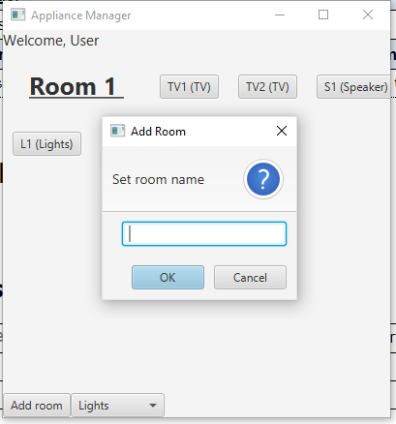

When the user left clicks a room to add an appliance

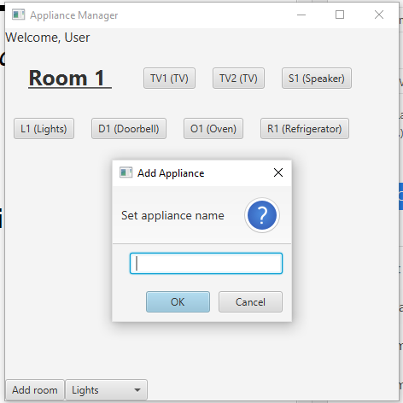

UI window for when the user clicks on an appliance of type TV

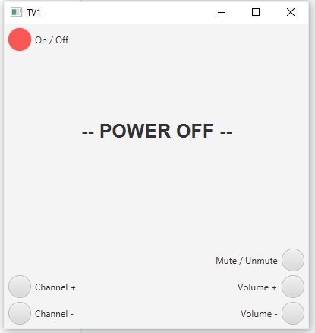

When the user clicks 'On', increases the volume to 60, and increases the channel to 5

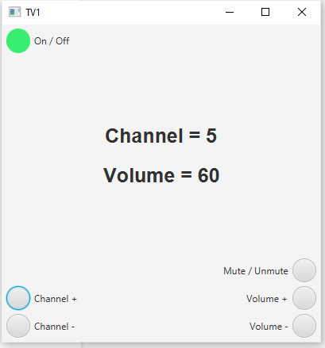

when the user clicks on 'Mute'

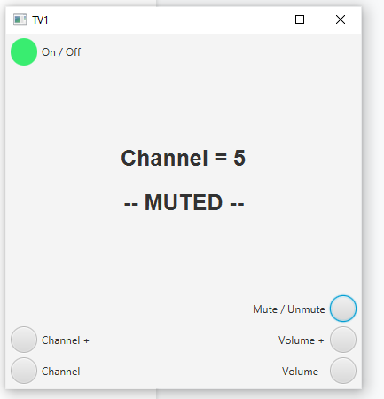

UI window for when the user clicks on an appliance of type Speaker

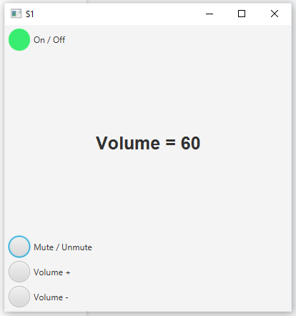

When the user clicks on 'Mute'

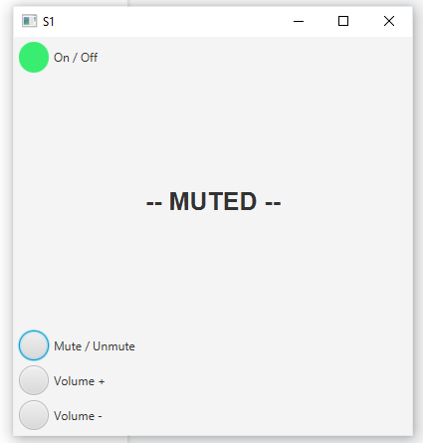

UI window for when the user clicks on an appliance of type Light

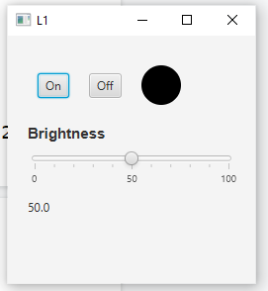

When the user clicks on 'On' while the lights are turned off

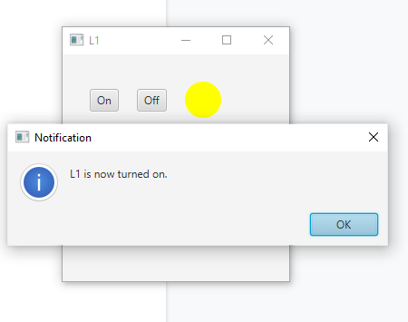

UI window for when the user clicks on an appliance of type Doorbell

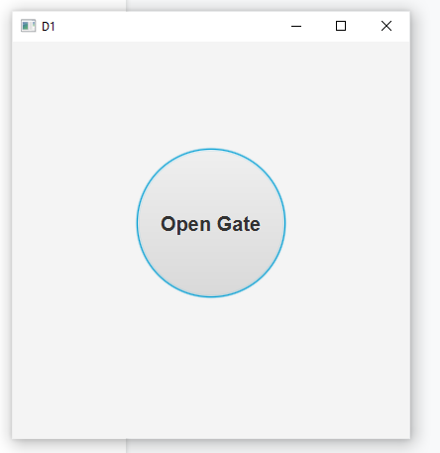

When the user clicks on 'Open Gate'

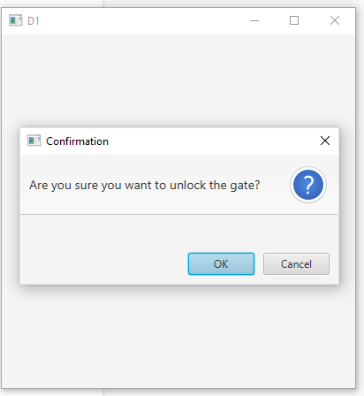

UI window for when the user clicks on an appliance of type Oven

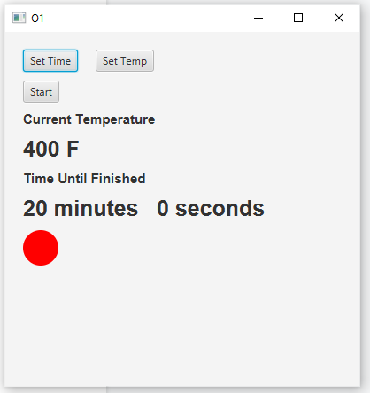

When the user clicks on 'Set Time'

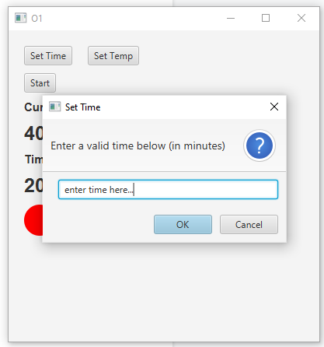

When the user clicks on 'Set Temp'

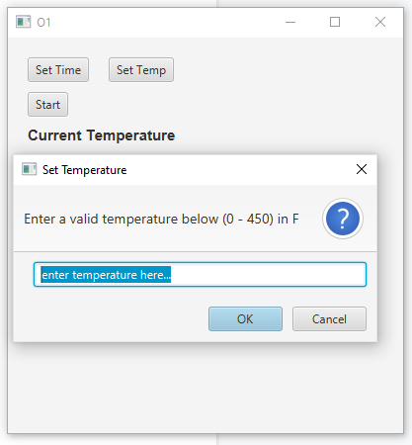

When the user clicks on 'Start'

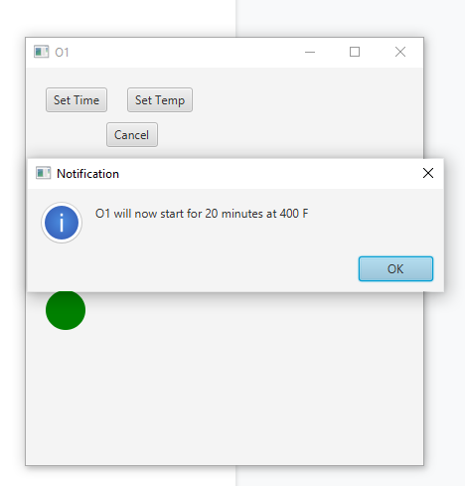

Timer counting down after the timer has started.

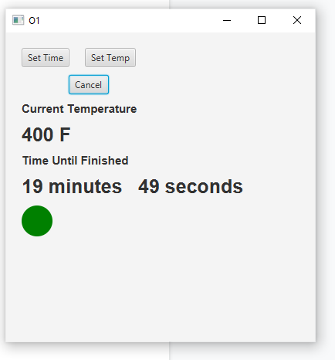

UI window for when the user clicks on an appliance of type Refrigerator

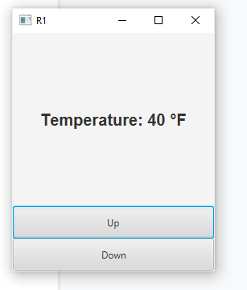

When the user left clicks on the “Up” button to increase the temperature up to 50 °F.

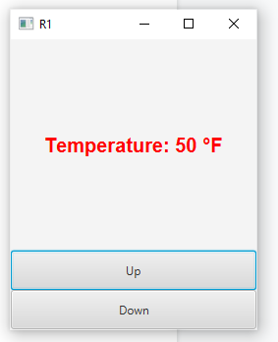

When the user left clicks on the “Down” button to decrease the temperature down to 30 °F.

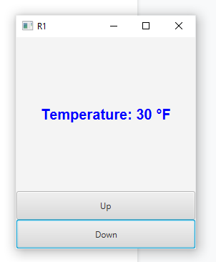

UI window for when the user clicks on an appliance of type Air conditioner

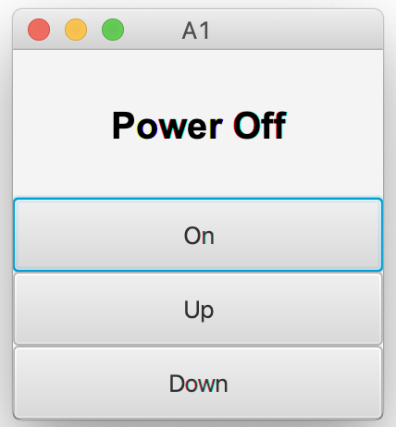

When the user clicks on “On” button

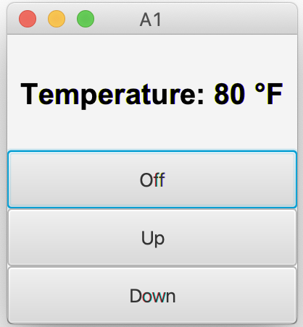

## Glossary

|  |  |
| --- | --- |
| home screen | the state of the program displaying every appliance added to the account. |
|  |  |
|  |  |